Template for SEAS Submissions
Author name¹, Author name², Author name³, and Author name⁴
¹Affiliation1 details for first author to appear here, Illinois 60439, USA
²Affiliation2 details for second author to appear here, Illinois 60637, USA
²Affiliation2 details for second author to appear here, Cairo 11566, Egypt
³Affiliation3 details for third author to appear here, P.O. Box 43, Egypt
⁴Affiliation4 details for fourth author to appear here, California 92521, USA

Abstract
Established in 2022, Studies in Egyptian Archaeology and Science (SEAS) is an international open-access journal that covers the implementation of physical and biological sciences to Egyptian archaeology, philology and art history. SEAS invites contributions with a focus on dating, environmental studies, remote sensing and geophysics including satellite mapping, artefact studies, conservation science and biological anthropology including a strong Egyptological research focus and cultural theory in equal measure. Contributions are expected to be evidence-based, and to follow the highest scientific and ethical standards relevant to an international scientific community.
Keywords: Archaeology, Egyptology
DOI: 10.2018/SEAS000001

1. Introduction
In broad strokes, the story of the development of ancient Egypt as one of the world’s first civilisations emerging has often been told. First, by the ancient Egyptian themselves, later by Greek historians such as Herodotus who, like us, observed ancient Egyptian culture from a distance. Two hundred years after the first successful decipherment of ancient Egyptian hieroglyphs by Jean-François Champollion in 1822, and one hundred years after the discovery of the tomb of Tutankhamun by Howard Carter in 1922, the study on ancient Egypt has become more varied, detailed and informed by multidisciplinary approaches than ever. Theories, methods and archaeological practice have constantly been refined over the past 40 years. With the dramatic change experienced in the wake of cognitive-processional archaeology which still stresses the role of generalisation within theoretical thinking but also emphasises the importance of formulating hypotheses tested against data, archaeology accepted that material culture is an active factor in constituting the world then and now. As individuals and societies construct their own social realities, facts are interpreted within theory for them to be able to explain a specific historical event, a series or class of events, or even a more general process. This is where this journal hopes to become a tool sharp enough to impact on current and future trends, methods and practice.

2. SEAS Conferences
Studies in Egyptian Archaeology and Science (SEAS) has organised its international conference for 2023, Materials and Technology: Working with Ancient Egyptian Artefacts in the Field and in Museums, at the Nubia Museum in Aswan from November 24 to November 27, 2023.
The conference chair is Professor Martin Bommas, Professor and Museum Director at Macquarie University, Sydney, Australia, and Director of the Qubbet el-Hawa Research Project (QHRP) in Aswan, Egypt.

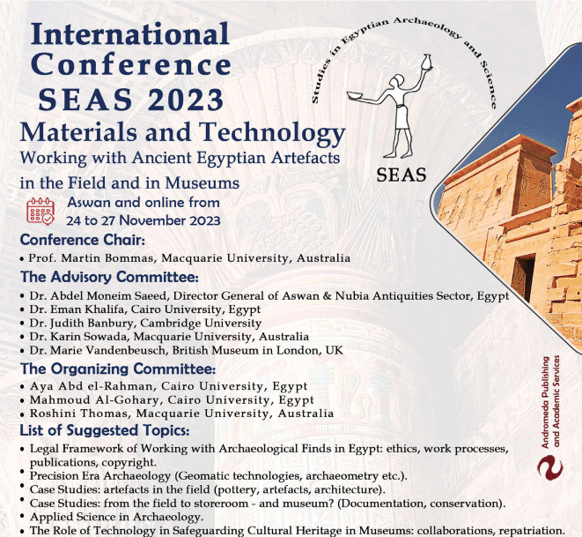
Figure 1: SEAS-2023.

Acknowledgements
This work is supported in part by XXX.

References
[1] E. Ma and G. Rajasekaran, Phys. Rev. D64, 113012 (2001).
[2] E. Ma, Phys. Rev. D70, 031901 (2004).
[3] B. Aharmim et al., Phys. Rev. C72, 055502 (2005)

